**A Seminar Report**

**on**

**Data Recovery**

In partial fulfillment of requirements for the degree of

Bachelor of Technology

In

Computer Science and Engineering

**SUBMITTED BY:**

**Narendra Dodwaria**

**14MI536**

**COMPUTER SCIENCE AND ENGINEERING DEPARTMENT**

**NATIONAL INSTITUTE OF TECHNOLOGY**

**HAMIRPUR – 177005**

**MARCH 2017**

**ACKNOWLEDGMENT**

I wish to express my sincere thanks to Ms. Garima Sharma, my seminar teacher, for providing me with all the necessary guidance for this report. I place on record, my sincere thanks to my roommates and batchmates, Sukhbir Singh and Saurabh Kumar, for their continuous encouragement and support. I am also grateful to my classmate, Bimalkanth lahuany. I am extremely thankful and indebted to him for sharing his expertise, and extending his sincere and valuable guidance and encouragement to me. I also thank my parents for their unceasing encouragement, support and attention. At last, I am grateful to the God for the good health and wellbeing that were necessary to complete this report...

**INDEX**

Abstract ........................................…............................................... 4

Introduction ..................................…............................................... 5

The essence of data recovery............….......................................…. 5

The scope of data recovery ...........….............................................. 5

Data Loss ...….……………....................…..................................... 6

Causes of Data Loss ..................….................................................. 7

Data Recovery .......….....….....................…..................................... 8

Data Recovery Techniques ………….........................................…. 9

Software Data Extraction ….....................…................................... 10

Recovery using Softwares …........................................................... 10

Recovery using Machines ..…….............................................…... 11

Scanning Probe Microscopy(SPM).….....…................................… 11

Magnetic Force Microscopy (MFM)….…….................................. 12

Scanning Tunneling Microscopy (STM) .….................................... 14

Conclusion ...……………………...…….….................................... 15

References …………………..…………..…............................…... 15

**FIGURE INDEX**

Figure 1 – Percentage of each causes....……..................................... 7

Figure 2 – User Interface of recuva ................................................. 11

Figure 3 – Scanning Probe Microscopy(SPM) ..................…........ 12

Figure 4 – Magnetic Force Microscopy (MFM)............................... 13

Figure 5 – Scanning Tunneling Microscopy (STM.)........................ 14

**Data Recovery**

**Abstract**

*Data recovery can be defined as it is the process or method of retrieving data from corrupted, unreachable, run-downed from secondary storage media when it cannot be accessed ordinarily. Generally the data are being retrieved from storage media such as internal or storage tapes, USB flash drive, external hard disk drives etc. Recovery may be essential due to physical or sensible damage to the file system that put an end to it from being mounted by the operating system.*

*There data loss can takes place because of either software damage or corrupt or hardware damage. Software damage can be fixed by using some softwares whereas data loss due to hardware damage we need machine techniques to recover the data like Scanning Probe Microscopy (SPM), Magnetic Force Microscopy (MFM), Scanning Tunneling Microscopy (STM) etc. The most often data recovery scheme hold of an operating system failure, in which case the goal is to simply copy all important or wanted files to another disk or another external drive. This can be adept by using a Compact Disk, many of which brings a means to mount the system drives and removable media, and to move the files from the system disk to the backup media with a file manager. Such many cases can often be reduced by disk persistently and partitioning storing valuable data files and then copies of them on a different partition from the unimportant operating system files.*

*There is an another scheme involves a disk-level breakdown which also comes under the physical damage, disk-level breakdown holds following aspects negotiate disk partition, file system or a hard disk breakdown. In any of these cases, the data cannot be easily read or accessible. For the various situations solutions involve reconstruction of the file system, hard disk restoration techniques ranging from software restoration of corrupted data to hardware based restoration of run-downed service areas to hardware replacement on a physically run-downed disk, or partition table.*

**Data Recovery**

**Introduction**

* Data recovery is the process of restoring data that has been lost, accidentally deleted, corrupted or made inaccessible.
* It is the process of salvaging data from damaged, failed, corrupted, or inaccessible secondary storage media when it cannot be accessed normally. Recovery may be required due to physical damage to the storage device or logical damage to the file­ system

**The essence of data recovery :**

Data recovery means retrieving lost, deleted, unusable or inaccessible data that lost for various reasons like physical damage, logical damage etc.

Data recovery not only restores lost files but it can also recovers corrupted data as well.

There can various reasons for data loss such as software, hardware reasons that causes data loss and we can recover data by using software and by using machines.

**The scope of data recovery :**

There are so many phenomenon and forms on data problem, we can divide the objects or scope of data recovery according to different symptoms

* **System problem**
  + If we can not enter the system or the system is abnormal or computer closes down.
  + Sometimes Key files of system is corrupted or lost, there may be some bad track on hard disk, the hard disk can be damaged, There MBR or DBR may lost, or the CMOS setting is incorrect.
* **Bad track of hard disk**
  + There can be logic and physical bad track.
  + Logic bad track is mainly caused by incorrect operation, and it can be restored by software or hardware machines if there is physical damage takes place.
  + While physical bad track is caused by physical damage, which is considered as real damage, we can restore it by changing the partition or sector.
* **Partition problem**

Sometimes partition is identified as unformatted, or partition cannot be identified and accessed, partition recovery tools such as Partition Table Doctor can be used to recover data in these situations..

* **Files loss**

Files restoring tools such as Data Recovery Wizard can be used to recover data, if files are lost because of format, deletion, or Ghost clone error etc.

* **Password loss**

If files, database or account, system password is lost, some special decryption tools that correspond to certain data form such as Word, WinZip can be used.

* **Files repair**

For some reasons such as, the contents are changed so as they can not be read, or the contents are full of troubled characters, some files can not be accessed or used. In these situations, some special files data retrieving tools can be used to restore the files.

**Data Loss :**

Data loss is any process or event that results in data being corrupted, deleted and/or made unreadable by a user and/or software or application, or Data has accidentally been erased or data control structures have been overwritten.

Data has been corrupted or made inaccessible or Data is unable to be accessed from a previous functioning computer system or backup.

There are some causes that may leads to Data Loss :

* Sabotage, Natural Disaster
* Hardware Error, Software Corruption
* Virus Attack
* Human Error
* Intentional deletion
* Accidental overwriting of files

**Software related reasons**

Some Viruses, format, misclone, mis-partition, mis-operation, network deletion, power-cut during operation all may be the software reasons.

The symptoms are usually read error, mis-operation, can not find or open file, report no partition, not formatted, password lost and troubled characters use software tools to recover it. So called soft recovery means data can be recovered by using softwares.

**Hardware related reasons**

Sometimes data loss is because of hardware, such as power cut, head damage, circuit panel problem, bad sector in hard disk, etc. or

Sometimes data loss takes place because of these hardware problems the speed of hardware become slow, cannot operate successfully; cannot read data, etc

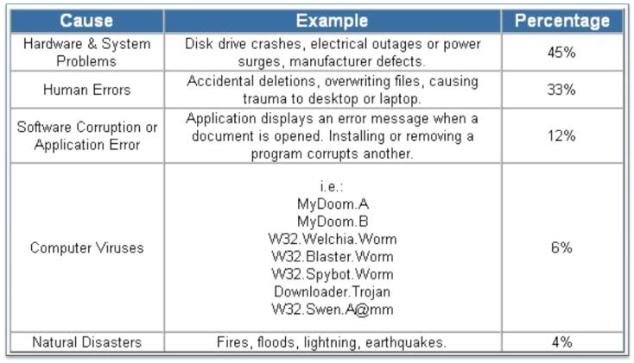

Figure 1 : Some statics about which cause is responsible for how much percentage of data loss

**Tips to Prevent Data Loss :**

Sometimes data loss can takes place because of upgradation in hardware or software so to prevent data loss don’t upgrade hardware or software without having a backup.

And there are some other tips to prevent data loss, Physically secure your system from intruders, Use firewalls and virus protection, Be prepared for physical disasters.

There are the things to know about **Data Loss**

* Data loss is disastrous at home, but for companies it causes setbacks in time as well as in money.
* According to observations “93% of the companies that experience data loss for more than 10 days file for bankruptcy within one year of the disaster.”
* If the data loss recovery is dealt with quickly or the necessary precautions are taken prior to any problem of data loss, the company could retrieve the data more easily or not experience a problem of data loss at all.

**About Data Recovery :**

Data Recovery is a technique to retrieving deleted/inaccessible data from electronic storage media (hard drives, removable media, optical devices, etc) or computer storage systems may fail, but the data stored on them is not always completely lost so that there is always some chances to data recovery and data recovery expertise even in the worst case.

There are occasions when damage to data is permanent and complete data recovery is not possible. However, some data is usually always recoverable so that don’t be hopeless even in the worst case. Data recovery professionals or experts can recover data from crashed hard drives, storage devices, servers, operating systems, desktops, and laptops using various proprietary data recovery tools and techniques.

**Data Recovery Tips**

**Do’s**

If You have really important data or working on them then backup your data frequently. If you believe there is something wrong with your computer shut it down, do not continue to power up because you may do more damage.

Package the drive properly when you send it to a data recovery specialist or to a data recovery company. You can cause additional damage to the hard drive if it is poorly packaged.

**Don’t s**

These are some tips which one should don’t

* Never remove the cover from the hard drive without any precautions, this will only cause further damage.
* Do not rest your computer on a movable object or piece of furniture. Vibration and impact can result in genuine damage to the hard drive.
* In the case where a drive has been exposed to water, fire or even smoke do not try to power up.

**Data Recovery Techniques :**

* **Use of software to recover data**

Sometime data loss can recovered by using various software and appropriate software for data recovery for a particular machine is depends on operating system of machine either it is Windows or Linux or mac OS or UNIX .

These are some software names which are used most widely according to operating system of One’s computer.

* + Recuva is data recovery software which is used to recover data from Windows OS and It is widely for Windows OS..
  + Knoppix, Trinity Rescue, Avira Rescue System , These are the most widely used softwares for data recovery in Linux Operating System.
* **Use of machines to recover data**

Sometimes data recovery can not be possible using softwares specially in case of Hardware damage like in hard disk damage, crash of head of hard drive etc. So that some hardware machines are used to recover data lost because of any hardware damage reasons.

**Most widely used machines to recover data :**

* Scanning Probe Microscopy (SPM)
* Magnetic Force Microscopy (MFM)
* Scanning Tunneling Microscopy (STM)

**Software Data Extraction :**

* Software Data extraction is the process of moving data off of the imaged drive to another destination location.
* Software Data extraction software scans sectors of the hard drive and then restructures the file system either in memory or another hard drive.
* The software can be used to copy the recoverable data to a destination location by Data Extraction.

**Software Recovery :**

Data loss can occur because the hard drive may have problems accessing the data it contains at a software or logical level. Using a program such as Norton GHOST, by making a entire sector copy (an perfect copy including all deleted information) of the hard drive, most data recovery programs searchs for deleted Master File Table entries to recover files.

If the MFT is corrupt or defective then this method will not work. Some data recovery programs will avoid the master file table and search all of the dish out clusters to try to find and recover files.

The user may send a failed hard disk drive to a private data recovery company that offers classified and secure data recovery.

The data recovery companies are deliberately perform part replacement of the base casting, spindle motor, heads, or the electronics board, etc. in a neat environment.

Parts replacement has historically been strong for data recovery about 40%-60% of the time.

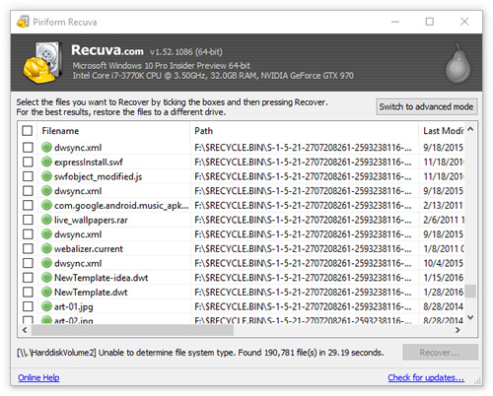

Figure 2 : Recuva

**Data Recovery using Machines :**

**Scanning Probe Microscopy (SPM)**

A technique that is used to measure and image surfaces at the atomic level.

Scanning probe microscopy is a division of microscopy that forms images of surfaces using a physical exploration that examine the specimen.

Scans an atomically sharp probe over a surface which produces a 3D topographic image of the surface at the atomic scale.

Uses a pointed magnetic tip attached to a flexible cantilever arranged close to the surface which is to be analyze, where it relate with the stray field emanating from the specimen to produce a topographic view of the surface.

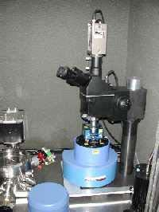

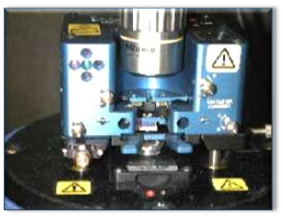

(a) (b)

Figure 3: Scanning probe microscopy (SPM)

**Magnetic Force Microscopy (MFM)**

Magnetic Force Microscopy is a new technique which images the spatial variation of magnetic forces on a sample surface. Magnetic Force Microscopy is derived from scanning probe microscopy and uses a sharp magnetic tip attached to a adjustable cantilever for investigation.

An image of the field at the surface is created by moving the sharp tip across the surface and calculating the force. Measurable old data will be present beside new data on the track which is generally neglected.

Together with software, Magnetic Force Microscopy can see past various kinds of data loss/removal. Each track contains an image of everything ever written to it, but each layer gets progressively smaller the earlier it was written.

Techniques can spot data by looking at the minute sampling region to precisely spot the remnant magnetization at the track edges. Measurable old data will still be present beside the new data on the track which is generally neglected.

Together with the softwares, Magnetic Force Microscopy can be calibrated to see past various kinds of data loss/removal and it can also do mechanized data recovery. It turns out that each track includes an image of everything ever written to it, but that the contribution from each layer gets increasingly smaller the further back it was made.

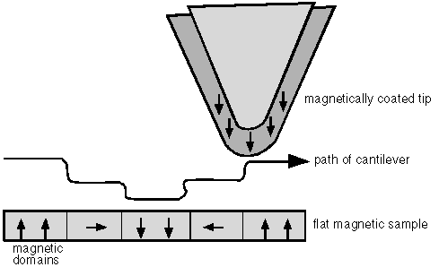

Fig 4: MFM looks at the minute sampling region to detect magnetization at track edges.



Figure 4: MFM image showing the bits of a hard disk

**Scanning Tunneling Microscopy (STM)**

A STM is an instrument for imaging surfaces at the atomic level.

Scanning Tunneling Microscopy is a more recent alteration of Magnetic Force Microscopy which uses a exploration tip typically made by plating nickel onto a pre-patterned surface.

The probe is examined across the surface that is to be analyzed. Scanning Tunneling Microscopy spot and measures a weak electrical current flowing between the sample and the probe tip. The image is then created or generated in the same way as Magnetic Force Microscopy.

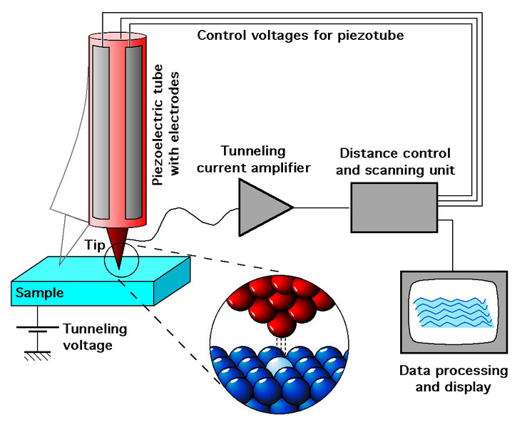

Figure 5 : STM

**Advantages and disadvantages :**

**Advantages**

* Many Data recovery tools can be used to undo mistakes that you made that resulted in to lost data.
* Data consistency can be maintained by data recovery.
* Digital forensics.

**Disadvantages**

* To successfully use a data recovery tool you will need to determine the cause of your data loss.
* Sometimes a simple reboot cause the over writing of data.
* Data security may be on risk.
* Sometimes Data Recovery may generate virus that is harmful to system.

**Conclusion :**

* There are various steps that should be implemented to help prevent data loss.
* Do not ever assume that data recovery is impossible, even in the worst cases, such as natural disasters data recovery specialists have been able to retrieve valuable data.
* There are many data recovery techniques that have justified to be partially successful or successful in recovering data that has been lost.
* Be ready for any physical disasters and always have a backup option either on online Cloud Storage or on another physical device.
* Sometimes there is difficulty in data recovery if data loss takes place because of natural disasters or sabotage for the end user. So user must have to take help from private companies to recover valuable data.

**References**

https://en.wikipedia.org/wiki/Scanning_tunneling_microscope

https://en.wikipedia.org/wiki/Scanning_probe_microscopy

http://www.seminarsTopics.com

http://www.geocities.com/spezzin_grazer/cap-4/cap4.htm

http://www.cs.auckland.ac.nz/~pgut001/pubs/secure_del.html